
A 10
SET NO : 1

Sreenidhi Institute of Science & Technology
(An Autonomous Institution)
Code No: 101EC05

B. TECH. I – Year II – Semester Examinations, July/Aug, 2011 (Regular)
ELECTRONIC DEVICES AND CIRCUITS (Common to EEE, ECE, ECM)

Time: 3 Hours Max. Marks : 70

Note : No additional answer sheets will be provided.

Part-A (Objective Type)
Max. Marks : 20

Answer all QUESTIONS.

1. Draw a neat block diagram of a CRT.
2. State Mass Action Law.
3. What are breakdown diodes? Name the two mechanisms of breakdown?
4. "Tunnel diode is a voltage controllable device", comment.
5. Define and interpret the following transistor ratings.
a) I_{CBO} b) I_{CEO}
6. In a transistor switch the relationship between collector current I_{C} and the base current I_{B} is__________________.
7. Why are FETs known as uni-polar devices?
8. Why is UJT referred to as current - controllable device?
9. Draw the comprehensive h-parameter model and approximate h-parameter model of a transistor. Highlights the assumptions made in approximate model.
10. Define ripple rejection factor in regulator power supplies.
Part – B
Max. Marks : 50
ANSWER ANY FIVE QUESTIONS.
EACH QUESTION CARRIES 10 MARKS.

1. a) Derive an expression for the deflection sensitivity of electro static field.

b) Draw the block diagram of CRO and explain each block.

2. a) What is the difference between the static and dynamic resistance of a P-N junction diode? Using the diode equation show that the dynamic resistance of an ideal P-N junction diode under for forward - bias condition is inversely proportional to the forward current.

b) What is meant by the term "Reverse - recovery time"?

3. a) What is the effect of the applied reverse - bias voltage on parasitic (transition) capacitance of a PN junction diode?

b) Explain the working of an SCR. With the help of V-I characteristics, describe the control action of the gate in terms of change in the V-I characteristics as a function of a gate current.

4. a) Derive the expression for the stability factor for self - bias configuration.

b) Design an Emitter - bias circuit with the following specifications"
I_{c} = 10mA ; V_{ce} = 4V; V_{cc} = 15 V; 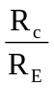 = 10; β = 130 and V_{BE} = 0.7V.

5. a) Derive the expression for a Av and A_{I}, R_{i} and R_{o} of CE amplifier. Configuration using simplified h-parameter equivalent models.

b) For the BJT configuration shown below, determine the following
i) V_{i} ii) Z_{i} iii) A_{v} iv) A_{vs}
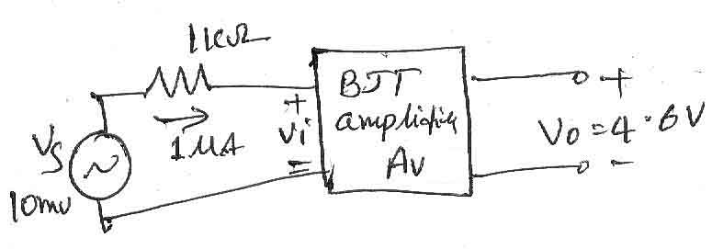

6. a) Draw the cross sectional view of an N-Channel JFET and explain its principle of operation.

b) An experimental setup using a JFET gave the following readings with V_{gs} = 0V and V_{ds} = 15V; determine the values of r_{d}, g_{m}, A_{v} and type of JFET.

7. a) Derive expression for lower cutoff and upper cutoff frequencies of an RC coupled amplifier and explain 3 dB band width.

b) An amplifier has 40 dB voltage gain. If the input is a snusodial signal having 20mV RMS find the output of the amplifier.

8. Write a brief note on
a) Voltage multipliers b) voltage regulators.

-- 00 -- 00 --

